**5. ReactJS-HOL**

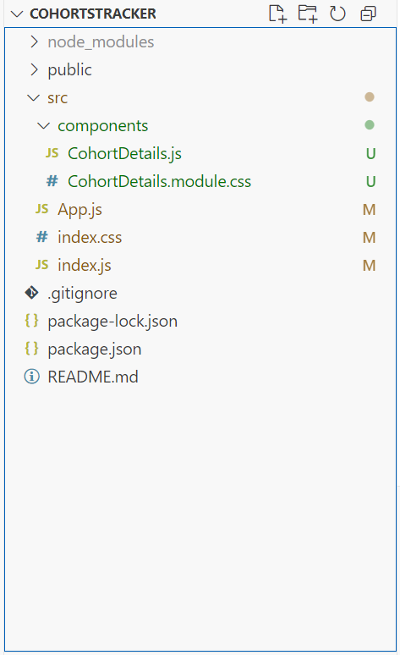

**index.js**  
  
import React from 'react';

import ReactDOM from 'react-dom/client';

import App from './App';

import './index.css';

const root = ReactDOM.createRoot(document.getElementById('root'));

root.render(

<React.StrictMode>

<App />

</React.StrictMode>

);

**App.js**  
import React from 'react';

import CohortDetails from './components/CohortDetails';

function App() {

return (

<div className="App">

<CohortDetails />

</div>

);

}

export default App;

**CohortDetails.js**  
  
import React from 'react';

import styles from './CohortDetails.module.css';

const cohortData = [

{

name: 'INTADMFD10 - .NET FSD',

startDate: '22-Feb-2022',

status: 'Scheduled',

coach: 'Aathma',

trainer: 'Jojo Jose'

},

{

name: 'ADM21JF014 - Java FSD',

startDate: '10-Sep-2021',

status: 'Ongoing',

coach: 'Apoorv',

trainer: 'Elisa Smith'

},

{

name: 'CDBJF21025 - Java FSD',

startDate: '24-Dec-2021',

status: 'Ongoing',

coach: 'Aathma',

trainer: 'John Doe'

}

];

const CohortDetails = () => {

return (

<div style={{ padding: '20px' }}>

<h2>Cohorts Details</h2>

{cohortData.map((cohort, index) => (

<div key={index} className={styles.box}>

<h3

style={{

color: cohort.status.toLowerCase() === 'ongoing' ? 'green' : 'blue'

}}

>

{cohort.name}

</h3>

<dl>

<dt>Started On</dt>

<dd>{cohort.startDate}</dd>

<dt>Current Status</dt>

<dd>{cohort.status}</dd>

<dt>Coach</dt>

<dd>{cohort.coach}</dd>

<dt>Trainer</dt>

<dd>{cohort.trainer}</dd>

</dl>

</div>

))}

</div>

);

};

export default CohortDetails;

**CohortDetails.module.css**  
  
.box {

width: 300px;

display: inline-block;

margin: 10px;

padding: 10px 20px;

border: 1px solid black;

border-radius: 10px;

vertical-align: top;

}

dt {

font-weight: 500;

}

**index.css**

body {

font-family: sans-serif;

background-color: #f8f9fa;

}

